Session 6

1. Write down the null hypothesis (H0) and alternative hypothesis (H1) for the following scenario: You believe that people spend more time on Instagram than on YouTube daily.

Scenario: You believe that people spend more time on Instagram than on YouTube daily.
- Null Hypothesis (H₀): People spend the same or less time on Instagram than on YouTube.
- Alternative Hypothesis (H₁): People spend more time on Instagram than on YouTube
2. Given the data: Group A (users shown a new Zomato home page) had an average order value of ₹350 from 30 users, and Group B (old home page) had an average order value of ₹320 from 30 users. Assume both groups have a standard deviation of ₹50. Calculate the p-value using a two-sample t-test (you may use Python, R, or an online calculator), and decide whether to accept or reject the null hypothesis at a 0.05 significance level.<br><br><em><strong>Hint:</strong> Use scipy.stats.ttest_ind in Python or any online t-test calculator if you are not comfortable with code.</em>

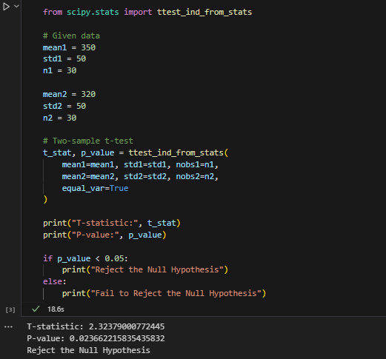
3. Pick any feature from your favorite app (like the new dark mode in WhatsApp or a redesigned payment button in Paytm) and describe how you would set up an A/B test for it. Clearly state what your control and variant groups would be, what metric you would measure, and what your null and alternative hypotheses are.
Feature: WhatsApp Dark Mode
- Control Group (A): Users using the current light mode.
- Variant Group (B): Users using the new dark mode.
- Metric: Average daily usage time (minutes).
- Null Hypothesis (H₀): Dark mode does not change user engagement.
- Alternative Hypothesis (H₁): Dark mode increases user engagement.
4. Suppose you run an A/B test for a new 'Add to Wishlist' button design on Flipkart. Out of 1000 users, 520 clicked the new button versus 480 who clicked the old button. Without doing detailed calculations, explain if this difference is likely to be significant or just due to chance. Briefly explain how the p-value helps you decide.
The difference of 520 vs 480 clicks suggests the new button performs better. However, a statistical test is needed to determine whether this difference is significant or occurred by chance.
The p-value helps make this decision:
- If p-value < 0.05, the difference is statistically significant, and the new button is likely better.
- If p-value ≥ 0.05, the difference may be due to random chance, so we do not conclude that the new button is better.

